1940223_paired_ttest–1-.R

pranav

2020-09-18

QUESTION 1

Vernier = c(2.265, 2.267, 2.264, 2.267, 2.268, 2.263, 2.264, 2.258)  
Micrometer = c(2.270, 2.268, 2.269, 2.273, 2.270, 2.270, 2.268, 2.268)

Here, we have two measurements on the same entities (same cylinders), but with differing conditions (measurement tool). Hence, these samples are paired samples.

AIM

#

We need to see if the change in the measurement tool causes significant change in the sample. In other words, we want to use these samples to generalise (for the whole population of cylidrical rods) whether the measurements of vernier calliper and micrometer on the same entities are significantly different.

CHECKING ASSUMPTIONS

#

Assumption 1…

shapiro.test(Vernier)

##   
## Shapiro-Wilk normality test  
##   
## data: Vernier  
## W = 0.89104, p-value = 0.2393

We have that p = 0.2393 > 0.05, hence hence the sample may be said to be taken from a normal distribution.

#  
shapiro.test(Micrometer)

##   
## Shapiro-Wilk normality test  
##   
## data: Micrometer  
## W = 0.82605, p-value = 0.054

We have that p = 0.054 > 0.05, hence the sample may be said to be taken from a normal distribution.

#

Assumption 2…

#

Since the measurement of one cylindrical rod does not affect the measurement of another, we can say that each sample’s each observation is independently taken.

#

Assumption 3…

#

Since the samples are taken from the same entities, and since both samples only differ in measurement tools and not in some quality affecting the entities, we may say that the variances of the populations of the samples are equal. Verifying with f-test…

var.test(Vernier, Micrometer)

##   
## F test to compare two variances  
##   
## data: Vernier and Micrometer  
## F = 3.5, num df = 7, denom df = 7, p-value = 0.1204  
## alternative hypothesis: true ratio of variances is not equal to 1  
## 95 percent confidence interval:  
## 0.7007134 17.4821823  
## sample estimates:  
## ratio of variances   
## 3.5

We see that p = 0.1204 > 0.05, hence we can say that the variances of the sample populations are similar enough to be considered equal.

#

Assumption 4…

#  
boxplot(Vernier, Micrometer, names = c("Vernier", "Micrometer"), outline = TRUE)

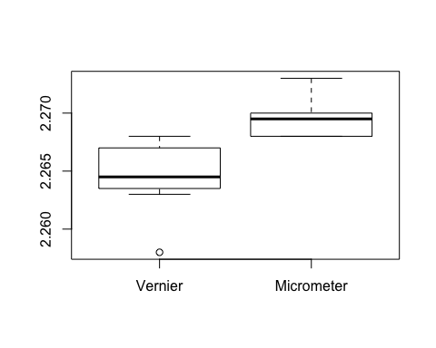

There is only one outlier in Vernier sample… We may proceed.

#

PAIRED T-TEST

t.test(Vernier, Micrometer, , paired = TRUE)

##   
## Paired t-test  
##   
## data: Vernier and Micrometer  
## t = -5, df = 7, p-value = 0.001565  
## alternative hypothesis: true difference in means is not equal to 0  
## 95 percent confidence interval:  
## -0.007364624 -0.002635376  
## sample estimates:  
## mean of the differences   
## -0.005

We see that p = 0.001565 < 0.05, hence we reject the null hypothesis that the sample populations are the same. Hence we conclude that the sample populations are different. Hence, we can say that the change in measurement tool from Vernier calliper to micrometer causes significant difference in measurement of cylidrical rods, in general.